Introduction

**If you are looking to install an FTP server, you can’t beat the simplicity of VSFTPD.**

FTP stands for File Transfer Protocol. It has been a standard method for transferring files between computers for decades.

Although security measures have been added, FTP is by nature an insecure method for transferring files. However, it can be useful when making files available to multiple users, or when working in a secure and private network.

This guide will show you how to configure and **install an FTP server using VSFTPD on CentOS 7.**

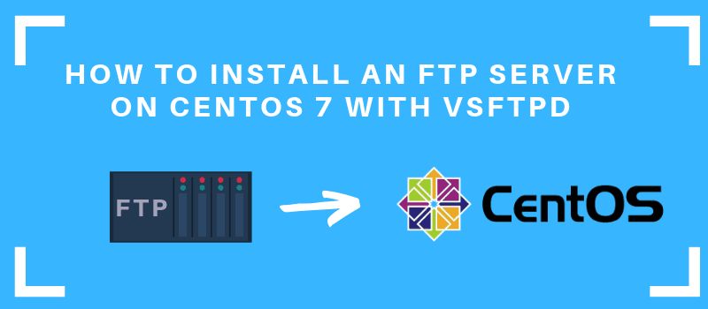

Prerequisites

* Access to a [user account with sudo](https://phoenixnap.com/kb/how-to-create-add-sudo-user-centos) privileges
* The **yum**package manager, installed by default
* A text editor of your choice

## Install FTP Server on CentOS 7

### Step 1: Install FTP Service with VSFTPD

1. Start by updating the package manager:

sudo yum update

Allow the process to complete.

This guide uses the **VSFTPD** (VSFTPD stands for “Very Secure FTP Daemon software package”). It’s a relatively easy software utility to use for creating an **FTP server**.

2. Install VSFTPD software with the following command:

sudo yum install vsftpd

When prompted, type **Y** to allow the operation to complete.

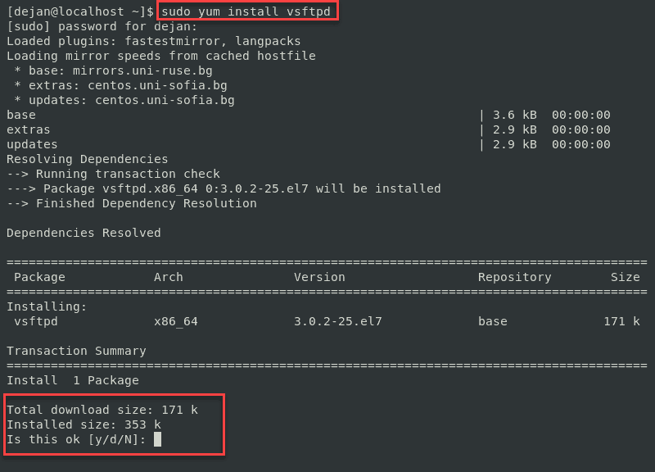

3. Start the service and set it to launch when the system boots with the following:

sudo systemctl start vsftpd

sudo systemctl enable vsftpd

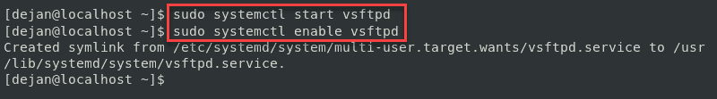

4. Next, create a rule for your firewall to allow FTP traffic on Port 21:

sudo firewall-cmd --zone=public --permanent --add-port=21/tcp

sudo firewall-cmd --zone=public --permanent --add-service=ftp

sudo firewall-cmd –-reload

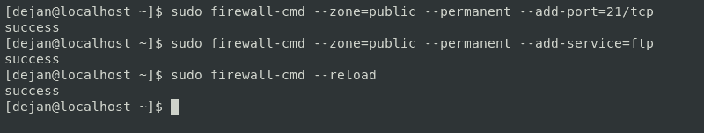

**Note:** If you use a different firewall application, refer to the documentation to configure it correctly for Port 21. Also, some FTP clients use Port 20, so you may wish to include that rule as well. Simply copy the first line, and replace 21 with 20.

### Step 2: Configuring VSFTPD

The behavior of the FTP service on your server is determined by the **/etc/vsftpd/vsftpd.conf** configuration file.

1. Before starting, create a copy of the default configuration file:

sudo cp /etc/vsftpd/vsftpd.conf /etc/vsftpd/vsftpd.conf.default

This ensures that you have a way to return to the default configuration, in case you change a setting that may cause issues.

2. Next, edit the configuration file with the following command:

sudo nano /etc/vsftpd/vsftpd.conf

3. Set your FTP server to disable anonymous users and allow local users.

Find the following entries in the configuration file, and edit them to match the following:

anonymous_enable=NO

local_enable=YES

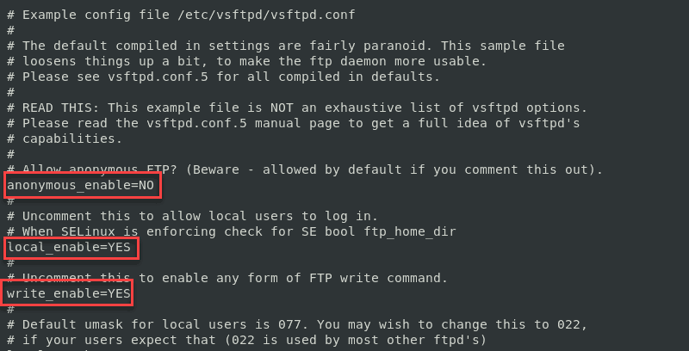

This is an important step. Anonymous access is a risky – you should avoid it unless you understand the risks.

4. Next, allow a logged-in user to upload files to your FTP server.

Find the following entry, and edit to match as follows:

write_enable=YES

**Note**: By default, this line starts with a **#** **sign** to indicate it’s a comment. Commenting is a useful way to turn commands on and off. The # sign can also be used to make notes in the file without the system interpreting them as instructions.

5. Limit FTP users to their own home directory. This is often called ***jail*** or ***chroot jail***. Find and adjust the entry to match the following:

chroot_local_user=YES

allow_writeable_chroot=YES

**Note**: for test purposes, the **allow_writeable_chroot=YES** option will create a functioning FTP server that you can test and use. Some administrators advocate the use of the **user_sub_token** option for better security.

Refer to the [vsftpd documentation](http://vsftpd.beasts.org/vsftpd_conf.html) for more information on this option.

6.The **vsftpd** utility provides a way to create an approved user list. To manage users this way, find the **userlist_enable** entry, then edit the file to look as follows:

userlist_enable=YES

userlist_file=/etc/vsftpd/user_list

userlist_deny=NO

You can now edit the **/etc/vsftpd/user_list** file, and add your list of users. (List one per line.) The **userlist_deny** option lets you specify users to be included; setting it to **yes** would change the list to users that are blocked.

7. Once you’re finished editing the configuration file, save your changes. Restart the **vsftpd** service to apply changes:

sudo systemctl restart vsftpd

### Step 3: Create a New FTP User

1. To create a new FTP user enter the following:

sudo adduser testuser

sudo passwd testuser

The system should prompt you to enter and confirm a password for the new user.

2. Add the new user to the **userlist**:

echo “testuser” | sudo tee –a /etc/vsftpd/user_list

3. Create a directory for the new user, and adjust permissions:

sudo mkdir –p /home/testuser/ftp/upload

sudo chmod 550 /home/testuser/ftp

sudo chmod 750 /home/testuser/ftp/upload

sudo chown –R testuser: /home/testuser/ftp

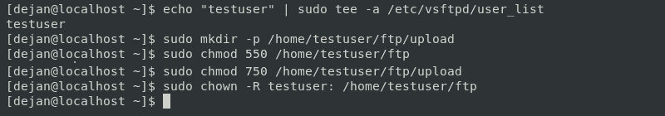

This creates a ***home/testuser*** directory for the new user, with a special directory for uploads. It sets permissions for uploads only to the /uploads directory.

4. Now, you can log in to your FTP server with the user you created:

ftp 192.168.01

Replace this IP address with the one from your system. You can [find your IP address in Linux](https://phoenixnap.com/kb/how-to-find-ip-address-linux) with the  **ip addr**  command.

The system should prompt you for a username – enter whatever username you created earlier. Type the password, and the system should log you in.

### Step 4: Test the FTP Server

To test the FTP server locally, use the command:

ftp localhost

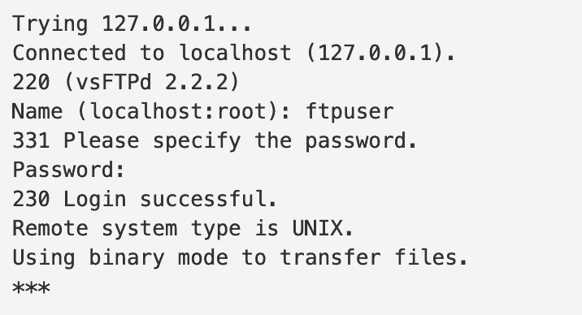

To test remotely, use the command:

ftp your.ftp.server.com

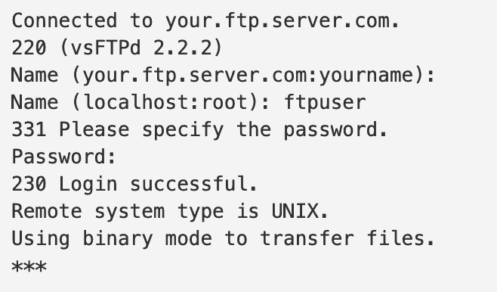

**Note:** While some security measures have been included in this guide, it is strongly recommended that you familiarize yourself with the latest security protocols before implementing an FTP server in a production environment. This is especially important if you’re creating an FTP server that’s open to the internet – many security breaches originate through the FTP protocol.

Conclusion

Now you know **how to set up and install an FTP server on Centos 7 with VSFTPD**. You should be able to login to your server via FTP and start transferring files.